**COST EFFECTIVENESS ANALYSIS OF EPIDURAL ANALGESIA COMPARED TO INTRAVENOUS OPIOIDS AS ANALGETIC AFTER MAJOR ABDOMINAL SURGERY AT DR. SARDJITO**

**Publication Manuscript**

**Submitted to Fulfill the Requirements to Achieve**

**Anesthesiology and Intesive Therapy Specialist Degree**



**Submitted by :**

**Krisna Hario Adiyatma**

**19/453462/PKU/18359**

**ANESTHESIOLOGY AND INTENSIVE THERAPY DEPARTMENT**

**FAKULTAS KEDOKTERAN, KESEHATAN MASYARAKAT DAN KEPERAWATAN UNIVERSITAS GADJAH MADA**

**RSUP DR. SARDJITO YOGYAKARTA**

**2023**

**PUBLICATION MANUSCRIPT**

**COST EFFECTIVENESS ANALYSIS OF EPIDURAL ANALGESIA COMPARED TO INTRAVENOUS OPIOIDS AS ANALGETIC AFTER MAJOR ABDOMINAL SURGERY AT DR. SARDJITO**

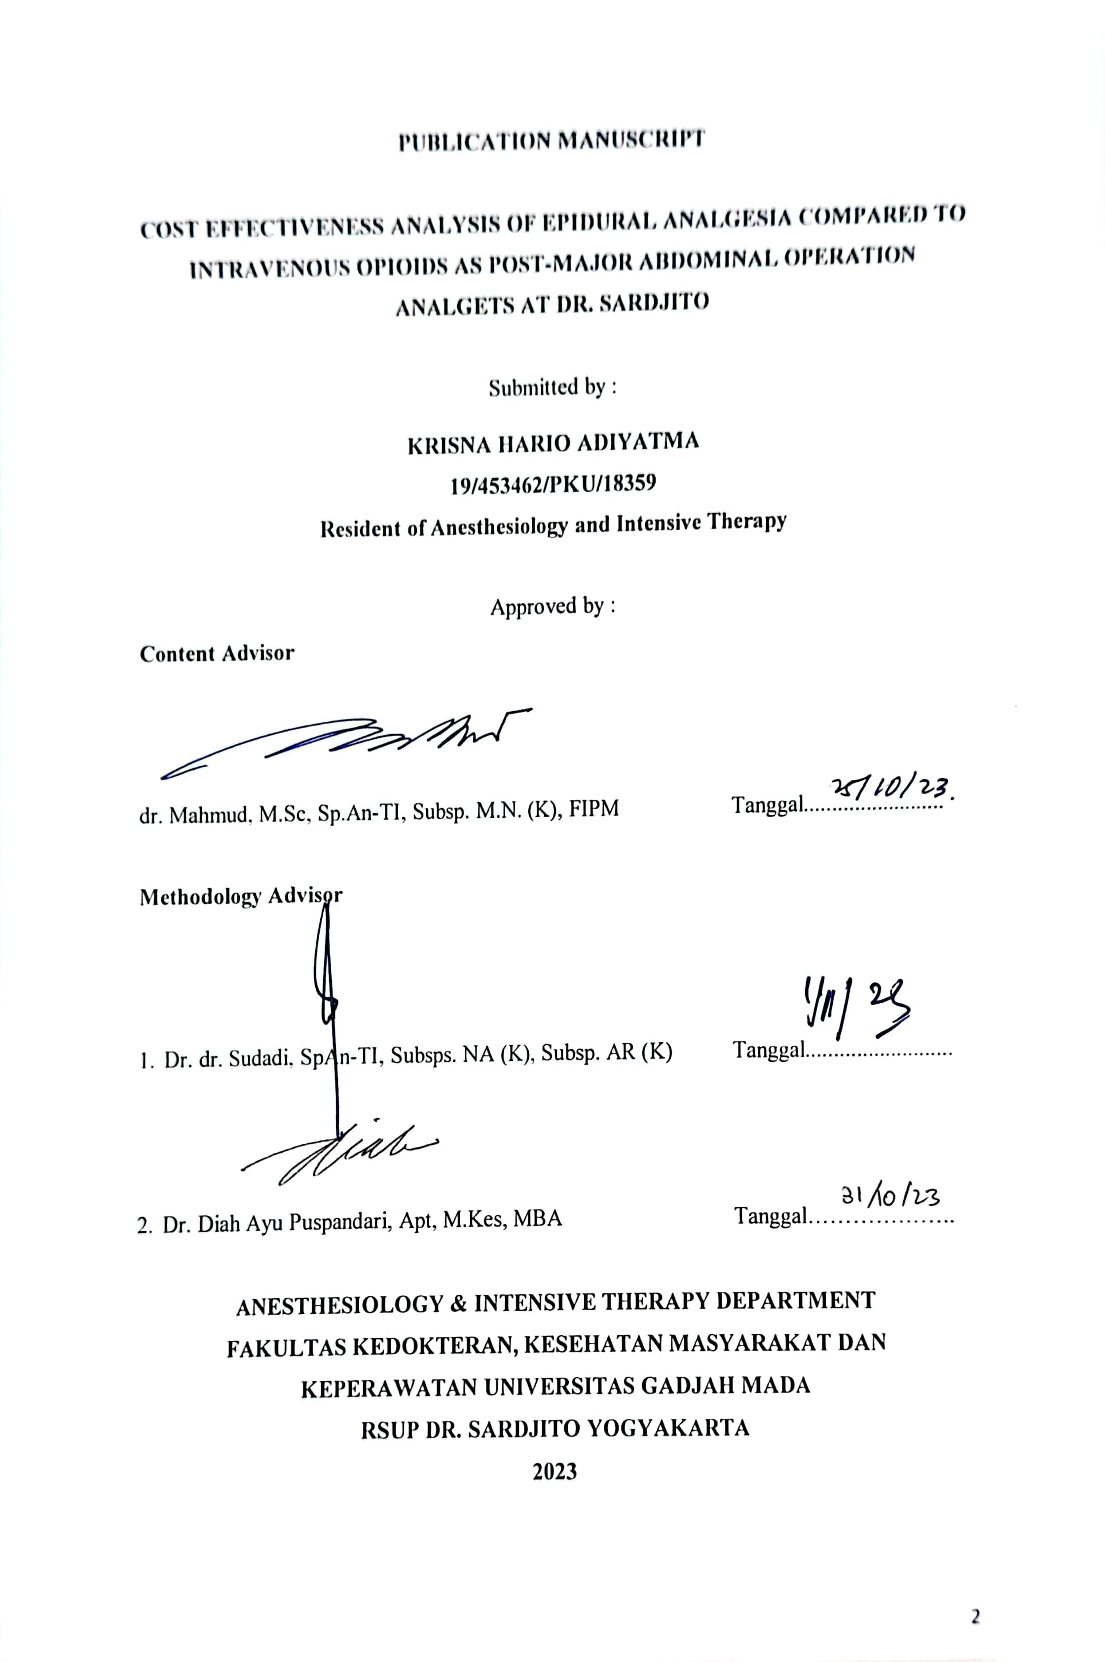

**COST EFFECTIVENESS ANALYSIS OF EPIDURAL ANALGESIA COMPARED TO INTRAVENOUS OPIOIDS AS ANALGETIC AFTER MAJOR ABDOMINAL SURGERY AT DR. SARDJITO**

**Krisna Hario Adiyatma, Mahmud, Sudadi, Diah Ayu Puspandari**

Anesthesiology & Intensive Therapy Department, Fakultas Kedokteran, Kesehatan Masyarakat dan Keperawatan Universitas Gadjah Mada RSUP Dr. Sardjito Yogyakarta

**ABSTRACT**

**Background :** One of the frequent post-operative complications is pain, which is experienced by more than 80% of patients and 75% of them experience post-operative pain of moderate to severe intensity. Major abdominal surgery is a surgical procedure with moderate to severe postoperative pain intensity. Analgesic approach strategies that are often used are intravenous opioids and epidural analgesia. Epidural analgesia is considered the analgesic therapy of choice for post-major abdominal surgery, but at a higher cost when compared with intravenous opioids. The differences in route of administration, efficacy and side effect profiles make it important to assess the cost effectiveness between the two approaches as part of hospital quality control and cost management.

**Objective :** To determine the cost effectiveness of epidural analgesia compared with intravenous opioids as analgetic after major abdominal surgery.

**Method :** This study used a descriptive analytical design with decision tree analysis to assess clinical outcomes and estimated costs for two alternative therapies. Research samples were taken retrospectively from September – December 2022 at RSUP Dr. Sardjito Yogyakarta, using simple random sampling. The Incremental Cost Effectiveness Ratio (ICER) value was assessed and Probabilistic Sensitivity Analysis (PSA) was carried out with Monte Carlo simulation using Microsoft Excel®.

**Results :** Epidural analgesia as anti-pain after major abdominal surgery has an Incremental Cost Effectiveness Ratio (ICER) value of IDR 20,857,416/pain free days. Probabilistic Sensitivity Analysis (PSA) produces data distribution with dominance in quadrant 3 of the CEA Plane.

**Conclusion :** The epidural analgesia strategy for pain relief after major abdominal surgery is a cheaper strategy but with slightly lower effectiveness than intravenous opioids at RSUP Dr. Sardjito. Epidural analgesia has an ICER value of IDR 20,857,416/pain free days, has the opportunity to be an alternative choice for post-major abdominal analgetic management that is cost effective.

.

**Keywords :** pain, post surgery, *cost effectiveness*

**Introduction**

More than 100 million people in the United States and Europe, and 312 million worldwide undergo surgery each year1. Postoperative pain is experienced by more than 80% of patients, with 75% of them experiencing pain of moderate to severe intensity2. Major abdominal surgery is one of the surgical procedures with moderate to severe postoperative pain intensity. The prevalence of moderate to severe intensity pain 24 hours after major abdominal surgery is 30-55%, in lower abdominal surgery it is 20% and minor pelvic surgery is 11% 3. Postoperative pain that is not handled properly will cause respiratory and cardiovascular side effects. unexpected and increases the duration of hospital stay with social and economic consequences for patients 2,4,5.

Postoperative anti-pain management varies, including neuraxial techniques (epidural, spinal), systemic intravenous, multimodal analgesia, and oral anti-pain drugs 2. Epidural analgesia and intravenous opioids are effective analgesia techniques of choice in patients after major abdominal surgery 6–8 .

The use of intravenous opioids is associated with the risk of postoperative side effects such as postoperative nausea vomiting (PONV), risk of ileus, sedation and dizziness which increases the duration of hospital stay and increases medical costs 8,9. Epidural analgesia is associated with greater cost and resource requirements. In addition, epidural analgesia requires special equipment and techniques and has limitations in use in daily practice such as contraindications and technique failure 8,10.

One pharmacoeconomic evaluation is a cost effectiveness analysis to see the possible benefits of other interventions in improving health status compared to the costs incurred. Several studies have shown that epidural analgesia is more effective but at a greater cost than intravenous opioids 8,10.

Based on this background, this study is the first to analyze the cost-effectiveness of anti-pain after major abdominal surgery between epidural analgesia and intravenous opioids at Dr. Sardjito Hospital. This is important to research as part of the quality control system and health cost control by hospitals and the Social Security Administering Body (BPJS), so that it requires health service providers including hospitals and doctors to be able to choose post-operative painkillers with the best effectiveness and cost for patients.

**Methods**

This research is a descriptive analytical study with approval from the Research Ethics Commission of the Faculty of Medicine, Public Health and Nursing, Gadjah Mada University number KE/FK/0921/EC/2023 and approval from the Education and Research Section (Diklit) of RSUP Dr. Sardjito with number DP.04.03/D.XI.2/15899/2023.

The research was conducted in the adult patient inpatient room at RSUP Dr. Sardjito Yogyakarta from September to December 2022, secondary data was taken retrospectively from medical records of adult patients undergoing major abdominal surgery who received pain relief therapy in the form of an epidural (Ropivacaine 0.125% and adjuvant fentanyl 1.25% with a volume of 10 cc intermittently per 8 hours) and intravenous opioids (continuous Fentanyl, dilution of 10 micrograms/milliliter, with a dose of 0.5 – 1 microgram/kilogram body weight/hour), multimodal analgesia in the form of Non-Steroidal Anti-Inflammatory Drugs with Paracetamol 1 gram/8 hours or with Ketorolac 30 mg /8 hours. The population of this study were patients who underwent major abdominal surgery, including digestive surgery involving intestinal resection with reconstruction in the form of anastomosis or stoma, whether performed by laparotomy or laparoscopy.

The sample size was calculated using a hypothesis test of the difference between two populations, with a drop out rate of 10%, so the total sample was 124 with each group of 62 samples selected using the simple random sampling method. Research subjects included in the analysis were those who met the inclusion and exclusion criteria.

Cost data was taken retrospectively through electronic medical records and from the finance department of RSUP Dr. Sardjito. Required data includes patient identity, ASA physical status, type and duration of surgical procedure, postoperative analgesic therapy (epidural or intravenous opioid), Numeric Rating Scale (NRS) value per 24 hours until the third day after surgery and any side effects that occur. The measurement scale used is the Numeric Rating Scale (NRS). The number of days with an NRS value ≤ 3 is counted as pain free days as a measurement of optimal post-operative analgesic management 2. Cost data includes administrative costs, direct medical costs, indirect medical costs and adverse effect costs obtained from the finance section of Dr. RSUP. Sardjito.

Descriptive demographic and clinical data of research subjects are displayed in proportions or mean/median. For each strategy that appears in the decision tree analysis, the proportion and total cost will be calculated. Pharmacoeconomic calculations are in the form of Average Cost Effectiveness Ratio (ACER) and Incremental Cost Effectiveness Ratio (ICER). In this research, the sensitivity analysis is in the form of probabilistic sensitivity analysis (PSA), to assess the impact of uncertainty on the decision tree analysis model. Data processing uses Microsoft Excel by carrying out iterations following the Monte Carlo simulation on a template containing the measured parameters. The results of the sensitivity analysis are displayed in a scatter plot diagram on the cost effectiveness analysis plane and Cost Effectiveness Acceptability Curve (CEAC).

**Results**

In this study there were 158 patients who underwent major abdominal surgical procedures, with 142 patients meeting the inclusion criteria. Of the 142 patients, 64 patients received intravenous opioid therapy in the form of continuous fentanyl as postoperative analgesia and 78 patients received epidural analgesia. A total of 62 samples from each therapy group were selected using a simple random sampling method using the Microsoft Excel ® program.

The characteristics of the research subjects can be seen in table 1. What was observed in this study were age, gender, financial security, ASA physical status, duration of surgery, pain scale with NRS at the 24th, 48th and 72nd hours after surgery, pain free days and length of treatment.

The duration of patient care in this study showed longer results in the intravenous opioid group with an average value of 10.0 days, compared to the epidural group of 9.3 days. The incidence of side effects in the epidural group was 10 patients (16.1%), while in the epidural group there were 9 patients (14.5%). Side effects include nausea, vomiting, numbness of the lower extremities, sepsis and death.

The data presented in Table 1 shows that in the epidural group, 46 patients had 3 pain free days (74.2%), 10 patients had 2 pain free days (16.1%), 2 patients had 1 pain free day ( 3.2 %), and 4 patients with 0 pain free days (6.5 %). Patients with an epidural as an analgesic after major abdominal surgery had a mean pain free days value of 2.60 days.

In the intravenous opioid group, the measurement of the number of pain free days is shown in Table 1, 47 patients had 3 pain free days (75.8%), 11 patients had 2 pain free days (17.7%), 2 patients had 1 pain free day (3.2%), and 2 patients with 0 pain free days (3.2%). Patients with intravenous opioids as an analgesic after major abdominal surgery had a mean pain free days value of 2.70 days.

Table 1. Characteristics of research subjects

|  |  |  |  |  |
| --- | --- | --- | --- | --- |
| **Characteristics** | **Analgesia epidural (n = 62)** | **Intravenous Opioid**  **(n = 62)** | **Total** | **Percentage**  **(%)** |
| Age   * 18 – 39 years old * 40 - 59 years old * > 60 years old | 12 (19,4 %)  29 (46,8 %)  21 (33,9 %) | 7 (11,3 %)  26 (41,9 %)  29 (46,8 %) | 19  55  50 | 15,3  44,4  40,3 |
| Sex   * Man * Woman | 28 (45,2 %)  34 (54,8 %) | 31 (50 %)  31 (50 %) | 59  65 | 47,6  52,4 |
| Financing   * BPJS * Other Health Insurance * Non-Insurance | 61 (50 %)  1 (50 %)  0 (0 %) | 62 (100 %)  0 (0 %)  0 (0 %) | 123  1  0 | 99,2  0,8  0 |
| ASA Physical Status   * ASA Physical Status I * ASA Physical Status II | 1 (1,6 %)  61 (98,4 %) | 2 (3,2 %)  60 (96,8 %) | 3  121 | 2,4  97,6 |
| Surgery Duration (Mean; Hours) | 3,7 | 3,5 |  |  |
| Post Operative Pain Scale   * 24 hours Post Operative * Mild (NRS 0-3) * Moderate (NRS 4-6) * Severe (NRS 7-10) * 48 hours Post Operative * Mild (NRS 0-3) * Moderate (NRS 4-6) * Severe (NRS 7-10) * 72 hours Post Operative * Mild (NRS 0-3) * Moderate (NRS 4-6) * Severe (NRS 7-10) | 49 (79,0 %)  13 (21,0 %)  0 (0 % )  54 (87,1 %)  8 (12,9 %)  0 (0 %)  57 (91,9 %)  5 (8,1 %)  0 (0 %) | 52 (83,9 %)  9 (14,5 %)  1 (1,6 %)  55 (88,7 %)  7 (11,3 %)  0 (0 %)  58 (93,5 %)  4 (6,5 %)  0 (0 %) | 101  22  1  109  15  0  115  9  0 | 81,5  17,7  0,8  87,9  12,1  0  92,7  7,3  0 |
| *Pain free days*   * 3 days * 2 days * 1 day * 0 day * Mean (days) | 46 (74,2 %)  10 (16,1 %)  2 (3,2 %)  4 (6,5 %)  2,60 | 47 (75,8 %)  11 (17,7 %)  2 (3,2 %)  2 (3,2 %)  2,71 | 93  21  4  6 | 75  16,9  3,2  4,8 |
| Inpatient Duration   * Mean (Days) | 9,3 | 10,0 |  |  |
| Side Effects   * Present * None | 10 (16,1 %)  52 (83,9 %) | 9 (14,5 %)  53 (85,5 %) | 19  105 | 15,3  84,7 |

The cost effectiveness analysis calculation consists of calculating the Average Cost Effectiveness Ratio (ACER) for each group and the Incremental Cost Effectiveness Ratio (ICER) for both groups. In this research, the following results were obtained:

Table 2. Direct and Indirect Medical Cost Components in The Group of Patients With Epidural Analgesia and Intravenous Opioid.

|  |  |  |  |  |
| --- | --- | --- | --- | --- |
|  | **Epidural Analgesia Group** | | **Intravenous Opioid Group** | |
| **Cost Component** | **Total Cost**  **(In Rupiahs)** | **Average Cost**  **(In Rupiah)** | **Total Cost**  **(In Rupiahs)** | **Average Cost**  **(In Rupiah)** |
| *Direct Medical Cost* | 2.201.383.695 | 35.506.189 | 2.328.209.346 | 37.551.764 |
| *Indirect Medical Cost* | 35.186.498 | 567.524 | 37.676.825 | 607.619 |
|  | TOTAL (In Rupiah) | 36.067.713 | TOTAL (Dalam Rupiah) | 38.159.454 |

Table 3. Calculation of pharmacoeconomic analysis of epidural and intravenous opioid groups

|  |  |  |
| --- | --- | --- |
| **Cost Parameter** | **Formula** | **Results** |
| *Average Cost Effectiveness Ratio* (ACER) Epidural | $$\frac{Epidural Cost}{Epidural Effectivity}$$ | Rp 13.874.505/*pain free days* |
| *Average Cost Effectiveness Ratio* (ACER) Opioid Intravena | $$\frac{Intravenous Opioid Cost}{Intravenous Opioid Effectivity}$$ | Rp 14.133.131/*pain free days* |
| ICER | $$\frac{Epidural Cost- Intravenous Opioid Cost}{Epidural Effectivity-Opioid Effectivity}$$ | Rp 20.857.416/*pain free days* |

From the results of calculating the Average Cost Effectiveness Ratio (ACER), the group of patients who received epidural analgesia therapy as a pain reliever after major abdominal surgery had an ACER of IDR 13,874,505/pain free days, while the ACER in the intravenous opioid group was IDR 14,133,131/pain free days. From calculating the Incremental Cost Effectiveness Ratio (ICER) value, we get a value of IDR 20,857,416/pain free days.

Estimated costs for the two groups based on decision tree analysis can be calculated, with the results for patients who received epidural analgesia as anti-pain after major abdominal surgery at Dr. .

In terms of funding sources, the majority of patients use Social Security Administering Agency (BPJS) insurance, showing that the epidural strategy has a better average claim difference (– IDR 8,526,465) compared to intravenous opioids (– IDR 11,265,920). So epidural analgesia is the best alternative choice as anti-pain therapy after major abdominal surgery at Dr. RSUP. Sardjito.

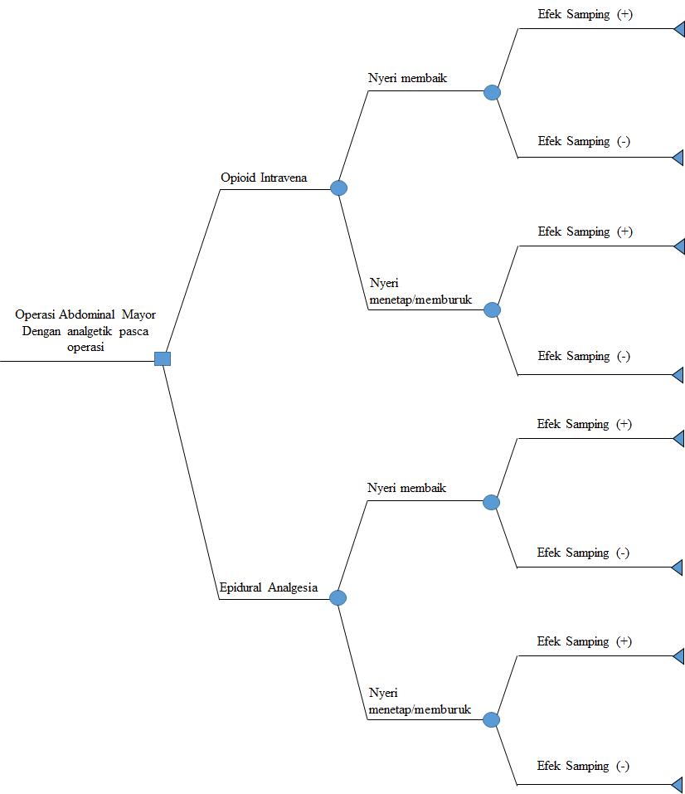

**0.5**

**0.5**

**0.048**

**0.331**

**0.024**

**0.097**

**0.048**

**0.323**

**0.032**

**0.097**

**0.379**

**0.121**

**0.370**

**0.129**

**52,447,308**

**35,138,339**

**62,275,704**

**35,308,610**

**49,280,656**

**34,842,519**

**32,113,376**

**34,894,332**

Figure 1. Decision Tree Analysis of epidural analgesia compared to intravenous opioids after major abdominal surgery at RSUP Dr. Sardjito

In this study, a probabilistic sensitivity analysis (PSA) was carried out on epidural analgesia which was considered to have better cost effectiveness than intravenous opioids as a standard treatment for postoperative pain. Probabilistic sensitivity analysis was carried out using Monte Carlo simulation with 1000 iterations using the Microsoft Excel® program and displayed on a diagram in the form of a scattered plot on the Cost Effectiveness Analysis (CEA) plane and Cost Effectiveness Acceptability Curve.

Figure 2. *Cost Effectiveness Analysis Plane* (CEA *Plane*)

In the CEA Plane diagram (Figure 2), the distribution of the point estimate value results of the epidural ICER values ​​obtained from iteration through Monte Carlo simulation is widely spread, especially in quadrant III, the results of the point estimate value distribution are quite narrow, indicating a fairly good level of confidence. Quadrant III in the CEA plane shows that epidural analgesia as a new therapy/technology that has been tested for cost effectiveness has lower effectiveness but also lower costs.

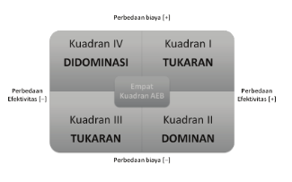

Gambar 3. Diagram Efektivitas Biaya

**Discussion**

This research is cost-effectiveness study to assess anti-pain therapy after major abdominal surgery at RSUP Dr. Sardjito. The effectiveness of post-operative anti-pain therapy is assessed up to 72 hours after surgery, mainly based on an assessment of the pain scale when the patient is at rest. The effectiveness of anti-pain can be assessed using several methods, time-weighted numeric rating score (NRS) up to 72 hours after surgery, numerical rating scale values ​​directly or by calculating pain free days (Bartha, Carlsson and Kalman, 2006; Tilleul et al., 2012; Babazade et al., 2019).

Several studies show the effectiveness of epidural analgesia as an anti-pain post-surgery, especially major abdominal surgery. Tilleul et al (2012) reported that the pain scale value 24 hours after surgery when the patient was in a condition with Numeric Visual Scale measurements was 2.4 (1.8-3.3) cm (ANOVA P value < 0.001) and 72% reported Numeric Visual Scale ≤ 3 cm (mild pain, no pain) when compared with intravenous opioid administration (P = 0.016) 8.

However, from a meta-analysis in 2022, there were three studies that showed no significant difference between epidural analgesia with a local anesthetic regimen plus opioid adjuvant compared to intravenous opioids in reducing pain at rest and activity (coughing) in the first 24 hours after surgery (-0.79 ; P = 0.78 and -0.43; P = 0.89) 11. Hazem et al in 2014 also showed a non-significant difference in pain reduction in the first 24 hours postoperatively with epidural compared to intravenous opioids (NRS 2 vs 2; p < 0.001), but with the advantages of an epidural such as less sedation and a better level of patient satisfaction (El Sayed Moawad and Mokbel, 2014)

In this study, the pain effectiveness results showed that the epidural group had a shorter average number of pain free days (2.60 days) than the intravenous opioid group (2.70 days) with a delta effect of 0.1. In the intravenous opioid group, there was 1 patient who suffered from severe pain (NRS 7-10) in the first 24 hours. However, if we look again at the data in table 9, patients in the epidural group complained more about moderate intensity pain (NRS 4-6) than those in the intravenous opioid group.

Several factors that can influence the adequacy of the epidural analgesia effect include epidural failure with the possibility of insufficient volume of epidural medication or shifting of the epidural catheter during patient treatment. The failure rate for epidural analgesia in a heterogeneous cohort study involving 2140 postoperative patients, showed a failure rate of 32% for thoracic epidurals and 27% for lumbar epidurals 13.

Assessment of length of stay and the incidence of side effects is one of the considerations when deciding whether epidural analgesia therapy can be chosen as a pain reliever after major abdominal surgery in addition to pharmacoeconomic analysis. In this study, the results showed that the duration of treatment for patients in the epidural group had a shorter duration of treatment, namely 9.3 days compared to the intravenous opioid group (10 days). In a meta-analysis study regarding the duration of treatment for patients who received epidurals when compared with a group of patients who received postoperative intravenous opioids, it was found that the results of epidural analgesia were superior with a shorter average Length of Stay (LOS) difference of 1.13 days (0 .29-1.98; p = .009) 11. Shorter Length of Stay is associated with faster patient care turnover.

In this study, the epidural group had side effects in 10 patients compared to 9 patients in the intravenous opioid group. From other studies, it shows a lower incidence of cardiovascular, respiratory and gastrointestinal side effects in the epidural group 14, however in another meta-analysis study shows a statistically insignificant difference regarding the incidence of side effects in the two groups with a Risk Ratio (RR) value of 0 .88 (0.62-1.03; p = 0.08) 11.

From a pharmacoeconomic point of view, the Average Cost Effectiveness Ratio (ACER), Incremental Cost Effectiveness Ratio (ICER), funding estimates are calculated using a decision tree analysis model and probabilistic sensitivity analysis (PSA). From the calculation of the Average Cost Effectiveness Ratio (ACER), the group of patients who received epidural analgesia therapy as a post-operative pain reliever had a lower ACER, namely IDR 13,874,505/pain free days compared to the ACER in the intravenous opioid group (IDR 14,133,131/pain free days ). This shows that it takes less money to achieve 1 pain free day in the epidural group.

From decision tree analysis modeling, taking into account the occurrence of complaints of improved or persistent pain and possible side effects (chance nodes), it was found that the estimated funding for the epidural group was lower, namely IDR 17,224,722 compared to the intravenous opioid group of IDR 18,116,831. In micro costing per unit using the epidural strategy is higher than when using the intravenous opioid strategy as anti-pain after major abdominal surgery, however after simulation using decision tree analysis modeling it was found that epidural has a lower estimated cost. This can also be influenced by the system of tariffs, discounts and recording of financing in the epidural group which still needs to be added.

The ICER value of epidural in this study was IDR 20,857,416/pain free day, which means that if you want to achieve an additional 1 pain free day when using an epidural as an anti-pain after major abdominal surgery, an additional fee of IDR 20,857.41 is required. When included in the Cost Effectiveness diagram, the ICER value of epidural analgesia is in Quadrant III (Trade Off Quadrant) which shows that epidural analgesia as a new therapy/technology that has been tested for cost effectiveness has lower effectiveness but also lower costs.

There are several types of sensitivity analysis that can be applied to pharmacoeconomic analysis models designed to analyze the impact of uncertainty from the prediction model. These include one-way sensitivity analysis, multiway sensitivity analysis, threshold analysis and probabilistic sensitivity analysis (PSA) (Ministry of Health, 2016).

In this research, probabilistic sensitivity analysis (PSA) was chosen to assess the uncertainty of the research model prepared. This is done by changing all parameters simultaneously and randomly using Monte Carlo simulation in the Microsoft Excel ® program, and the results are displayed in a Cost Effectiveness Analysis Plane diagram in the form of a scatter plot (Kristin, et al., 2016).

In assessing the point estimate value results on a scatter plot, interpretation is needed regarding the correlation between the two parameters measured on the X axis (therapy effectiveness) and the Y axis (cost). According to Birant et al, an illustration of the correlation between the two parameters can be seen from the distribution of data in the scatter plot diagram adapted to Figure 5 below (Birant et al., 2022)

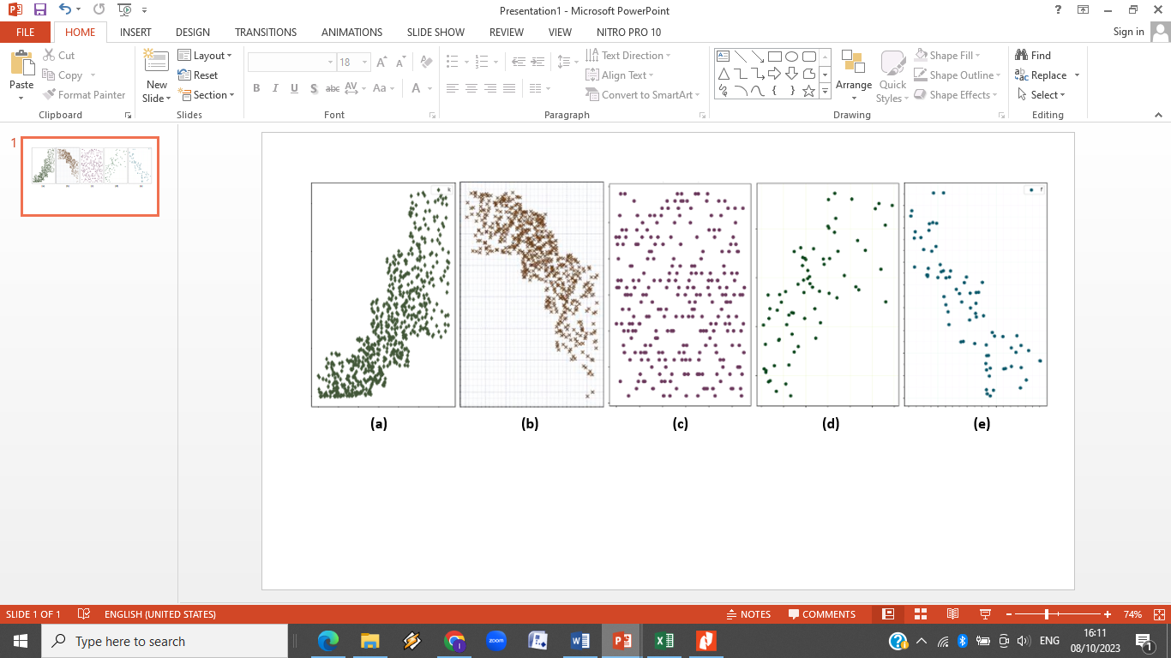

Figure 5. Types of Scatter Plot Results and Interpretation of Correlation. (a) strong-positive correlation; (b) strong negative correlation; (c) no correlation; (d) weak-positive correlation; (e) weak-negative correlation (Birant et al., 2022).

In the Cost Effectiveness Analysis Plane scatter plot diagram (Figure 3) it can be seen that the distribution of data on the X and Y axes shows a picture of weak correlation in positive and negative areas. However, the data distribution shows a narrow area around the linear progression line, indicating that the modeling structure used is sensitive enough to assess the desired predictions.

**Conclusion**

The epidural analgesia strategy for pain relief after major abdominal surgery is a cheaper strategy but with slightly lower effectiveness than intravenous opioids at RSUP Dr. Sardjito. Epidural analgesia has an ICER value of IDR 20,857,416/pain free days, has the opportunity to be an alternative choice for post-major abdominal pain relief that is cost effective.

**Recommendation**

For policy holders in hospitals, it is hoped that the research results can be used as consideration in recommendations for selecting anti-pain therapy for patients after major abdominal surgery. In addition, it is hoped that the results of this research can be used as material for consideration in preparing plans for equipment and human resource support to support the selected post-operative anti-pain therapy for patients. For Service Providing Professionals, as input on the best alternative anti-pain therapy that can be chosen for patients.

**REFERRENCES**

1. Culley, D. J., Richebe, P., Capdevilla, X., Rivat, C. (2018) ‘Persistent Postsurgical Pain : Pathophysiology and Preventive Pharmacologic Considerations’, *Anesthesiology* (XXX), pp. 1–18. doi : 10.1097/ALN.0000000000002238

2. Chou R, Gordon DB, De Leon-Casasola OA, et al. Management of postoperative pain: A clinical practice guideline from the American pain society, the American society of regional anesthesia and pain medicine, and the American society of anesthesiologists’ committee on regional anesthesia, executive commi. *J Pain*. 2016;17(2):131-157. doi:10.1016/j.jpain.2015.12.008

3. Sommer M, Rijke JM De, Kleef M Van, et al. Original Article The prevalence of postoperative pain in a sample of 1490 surgical inpatients. 2008:267-274. doi:10.1017/S0265021507003031

4. Gan TJ. Poorly controlled postoperative pain : prevalence , consequences , and prevention. 2017:2287-2298.

5. Lindberg M, Franklin O, Svensson J, Franklin KA. Postoperative pain after colorectal surgery. *Int J Colorectal Dis*. 2020;35(7):1265-1272. doi:10.1007/s00384-020-03580-4

6. Wu CL, Cohen SR, Richman JM, et al. Efficacy of postoperative patient-controlled and continuous infusion epidural analgesia versus intravenous patient-controlled analgesia with opioids: A meta-analysis. *Anesthesiology*. 2005;103(5):1079-1088. doi:10.1097/00000542-200511000-00023

7. Babazade R, Saasouh W, Naylor AJ, et al. The cost-effectiveness of epidural, patient-controlled intravenous opioid analgesia, or transversus abdominis plane infiltration with liposomal bupivacaine for postoperative pain management. *J Clin Anesth*. 2019;53(October 2018):56-63. doi:10.1016/j.jclinane.2018.10.003

8. Tilleul P, Aissou M, Bocquet F, et al. Cost-effectiveness analysis comparing epidural, patient-controlled intravenous morphine, and continuous wound infiltration for postoperative pain management after open abdominal surgery. *Br J Anaesth*. 2012;108(6):998-1005. doi:10.1093/bja/aes091

9. Oderda GM, Said Q, Evans RS, et al. Opioid-related adverse drug events in surgical hospitalizations: Impact on costs and length of stay. *Ann Pharmacother*. 2007;41(3):400-407. doi:10.1345/aph.1H386

10. Bartha E, Carlsson P, Kalman S. Evaluation of costs and effects of epidural analgesia and patient-controlled intravenous analgesia after major abdominal surgery. *Br J Anaesth*. 2006;96(1):111-117. doi:10.1093/bja/aei270

11. Viderman D, Tapinova K, Nabidollayeva F, Tankacheev R, Abdildin YG. Intravenous versus Epidural Routes of Patient-Controlled Analgesia in Abdominal Surgery: Systematic Review with Meta-Analysis. *J Clin Med*. 2022;11(9). doi:10.3390/jcm11092579

12. El Sayed Moawad H, Mokbel EM. Postoperative analgesia after major abdominal surgery: Fentanyl-bupivacaine patient controlled epidural analgesia versus fentanyl patient controlled intravenous analgesia. *Egypt J Anaesth*. 2014;30(4):393-397. doi:10.1016/j.egja.2014.06.002

13. Hermanides J, Hollmann MW, Stevens MF, Lirk P. Failed epidural: Causes and management. *Br J Anaesth*. 2012;109(2):144-154. doi:10.1093/bja/aes214

14. Popping, D. M., Elia, N., Van Aken, H.N., Marret, E, Schug, S.A., *et al* (2014) ‘Impact of Epidural Analgesia on Mortality and Morbidity’, *Annals of Surgery* 259(6). doi: 10.1097/SLA.0000000000000237.

15. Kementerian Kesehatan Republik Indonesia (2016). 'Pedoman Teknis Analisis Farmakoekonomi di Fasilitas Kesehatan'. Direktorat Jendral Kefarmasian dan Alat Kesehatan. Jakarta. ISBN : 978-602-416-109-5.